**VUE-JS C2-S2 – PRACTICE**

**DIRECTIVES**

*WARNING:*

* *WATCH VIDEOS 3,4,5,6 before practice!*

**EXERCICE-1**

You want to **show/hide** an element depending on VueJS data property.

1. Create a VueJS data “**count**” = 10
2. Using html elements and **v-if**, **v-else**, do the following :

* If the variable count is greater than 10 display “count is greater than 10”
* If it is less than 10 display “count is equal or less than 10”

From the console, change the value of “count”, and see how the app responds.

1. Do the same, but using **v-show**

**EXERCICE-2**

*Hint: If you are stuck, search the* [*documentation*](https://vuejs.org/v2/guide/list.html)

You want to loop through and print list in VueJS, List can be of numbers, arrays, and Objects using the v-for directive.

1. In the first list, loop to display all numbers from 1 to “number”
2. In the second list, loop to display all values in the array “countdown”
3. 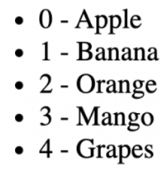In the third list, loop to display the index and name of the fruit, like below :
4. In the fourth list, loop to display the key, and value of each property of the object, like below :



**EXERCICE-3**

In this part, you will use directives to display the list of teachers.

1. Using the **v-text** directive, display the title from the “**title**” variable.
2. Using the **v-show** directive, and a Boolean variable (set as **true**), add a condition to only show the title if the variable is true.
3. Using the variable “**teachers**” and the **v-for** directive, create a **ul** to display the list of teachers.

Expected output :

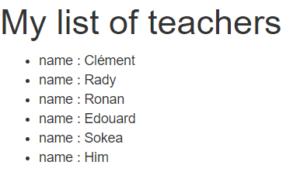

1. Using **v-if** and **v-else** and the “is_auth” variable, add the following behavior to your app :

* If the local storage contains a variable “**username**” of value “**Jonathan**”, then display the list
* Otherwise display a message

Sorry you are not authorized!

**EXERCICE-4**

1. Create 3 inputs and one H1 as follows:

* First Name
* Last Name
* Style

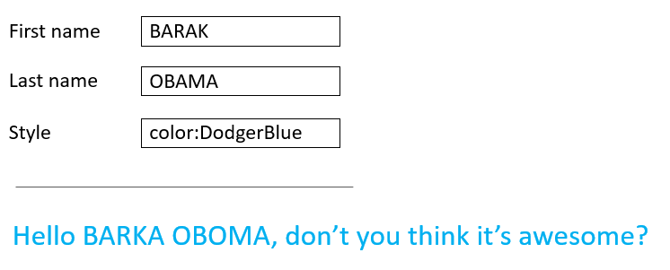

1. Add 3 vueJS data

* FirstName
* LastName
* Style

1. Use v-bind, and v-model, so that:

* First Name and Last Name change when the user change the values in the inputs.
* Style of the H1 should change when the style typed is a correct HTML style for text.

Example : “color:MediumSeaGreen”, “background-color:DodgerBlue” …

1. Use **v-cloak**, to change the interface so that nothing appears before the page is loaded.
2. Use **v-html** and the “**title**” variable to display the title as follow :



**EXERCICE-5**

Answer these questions in the EXERCICE-5.txt

Q1: Explain what is the difference between **v-text** and the use of **brackets** (like : {{my_variable}} ).

* When should you use the first, and when should you use the latter?

Q2: What is the difference between **v-text** and **v-html**?

* what can one do, that the other can’t ?

Q3: What is the difference of using **v-if/v-else-if/v-else** or **v-show** only ?

Q4: For now, what do you think about VueJS ? easy/hard, better/worse than simple javascript ?